Empowered
  - TheCIL’s 2018 Annual Report
Table of Contents
WHO WE SERVE 3
Total people served: 3
Age: 3
Gender: 3
Type of Disability: 3
A LETTER FROM OUR LEADERS 4
TheCIL Board Members 5
OUR MISSION 6
Our Principle Guidelines 6
Our History 6
SNAPSHOTS OF 2018 7
Empowerment through Adaptive Sports 7
Empowerment through Access 9
Empowerment through Peer Counseling 10
Empowerment through Self- Advocacy 11
TheCIL in the Community 13
Financial Review 15
Thank you to our supporters 16
How to Get Involved 18
Ed Roberts Awards 2019 19
Back Page 20
OUR LOCATIONS 20

WHO WE SERVE
TheCIL serves people with disabilities in the Northern section of Alameda County, which ranges from San Pablo to Oakland.

Total people served:
8,350 total people served

Age:
14-24: | 16%
25-59: | 43%
60+: | 41%

Gender:
Male: | 52%
Female: | 48%

Type of Disability:
Cognitive | 17%
Mental Health | 32%
Physical | 37%
Hearing | 1%
Vision | 4%
Other | 9%

A LETTER FROM OUR LEADERS

Dear Friends,
Thank you for your generous support to enable us to build programs that empower youth, adults, and seniors with disabilities to achieve. In the pages that follow we hope to share a few of the individual lives you have touched and empowered.

When the National Council for Independent Living added Youth as one of their pillars in 2016, we were in full support as we believe the future and power of our youth to be effective activists and advocates for their future. We immediately set out to build a platform so that young people with disabilities can aspire to dream and see beyond any boundaries of their disabilities. And this year has been monumental.

First, enrollment in our self-advocacy classes in the school districts have doubled. These classes build confidence for students to seize opportunities. Equally important has been our desire to create spaces for socialization. Our quad rugby team includes at least three college students, who in their first year playing together qualified for the National Championship in Arizona. Furthermore, our “Social Club” for youth with developmental and intellectual disabilities offers a shared space for them to interact with one another. Now we are geared to start our high school coding bootcamp, which helps students to acquire internships with our tech neighbors in San Francisco including Pinterest, Salesforce, and more.

We have also seen significant strides in our foundational core services that serves upwards of 7,000 people each year. We built our first ramp outside of Berkeley in a collaboration with Youth Alive, Living Well with a Disability for seniors is offered Spanish, and our Community Connections hosted the first Momentum Expo, a transportation and mobility showcase that brought in 500+ visitors onsite and online.

In the next year, TheCIL is poised to be the resource for people with disabilities so they have every chance to achieve their dreams. This will mean increasing support for Spanish speakers with disabilities, building home modifications outside of Berkeley, and ramping up the “Lifestyle” program. To reach these goals, we need to attract more support, and we are determined to do so.

Many of our exciting and rewarding undertakings this year are because of your partnership with us. Thank you for believing in us and the work that we do to empower people who aspire to achieve beyond the boundaries of expectations others have placed on them.

In power and gratitude,
Melissa Male | Stuart James
Board Chair | Executive Director

TheCIL Board Members

Melissa Male, Board Chair
Caleb vanDocto, Vice Chair
Eric Broque, Treasurer
Joan Leon, Secretary
Owen Kent
Sherri Rita
Peter Sussman

OUR MISSION

The Center for Independent Living (TheCIL) provides advocacy and services that increase awareness, collaboration, and opportunity among people with disabilities and the community at large.
TheCIL's programs provide people with skills, knowledge, and resources that empower them to eliminate damaging and stereotypical notions of disability so that they are able to strive toward realizing their full human potential.

Our Principle Guidelines
- The strong and most vibrant communities are those that include and embrace and people.
- A community-centric approach that creates targeted programming bsed on the needed individual communities.
- Individuals can be their own best advocates.

Our History
Founded in 1972, TheCIL is the original Indepen- dent Living Center in the country and the model for more than 400 centers nationally and worldwide.
TheCIL has offices in Alameda, Oakland, and Berke- ley, and provides services to eight cities in the East Bay Area. All our programs and services are avail- able to the community at no cost.
www.thecil.org

SNAPSHOTS OF 2018
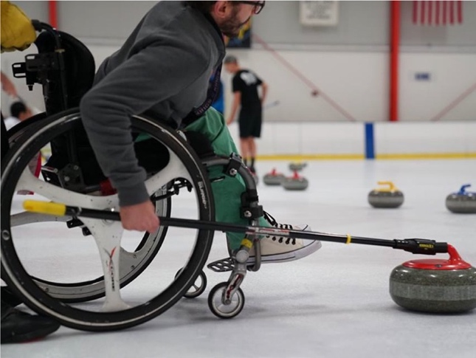
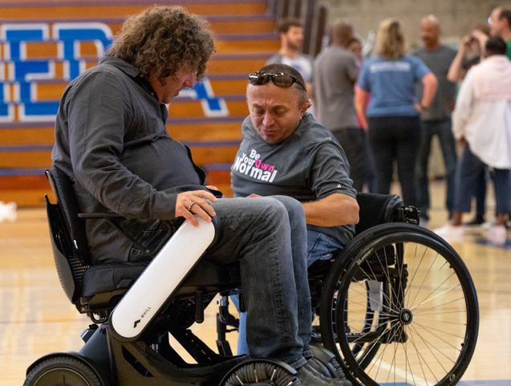
Figure 3. A young man in a wheelchair pushes a curling disc.
Figure 1. Executive Director Stuart James shows a male client features of the Whill power wheelchair.

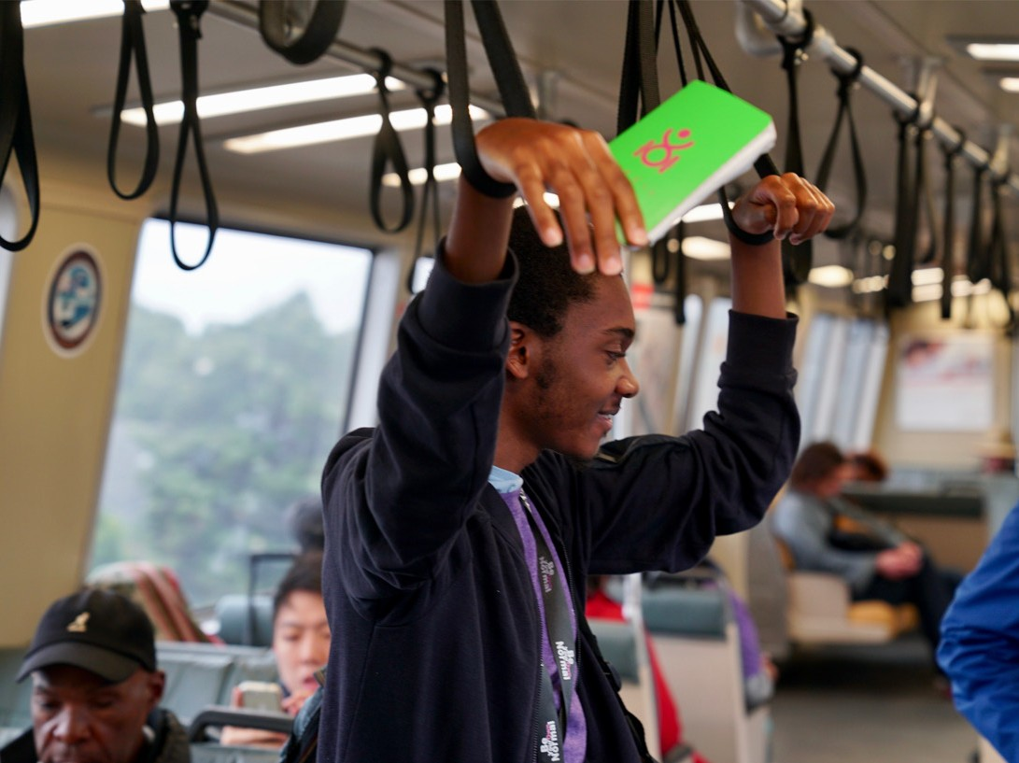
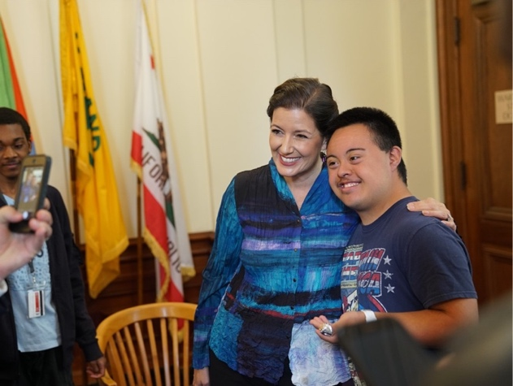
Empowerment through Adaptive Sports
150+ OUSD and AUSD students participated in an East Bay scavenger hunt that included navigating public transportation and building relationships with local business owners.
Figure 4. A young person holding onto the handrails as he stands in the BART train. He holds in his hand a small notebook from TheCIL.
TheCIL held our first adaptive curling event with the San Francisco Bay Area Curling Club at the Oakland Ice Center. We had skilled coaches show us why this sport is sweeping the nation.
Thecil's self-advocacy class decided to write the mayor of Oakland, Libby Schaaf, and she responded with an invitation to meet her in person!
Figure 2. Mayor Libby Schaaf takes a photo with a student
1,380 STUDENTS AND WORKING PROFESSIONALS PARTICIPATED IN THECIL'S DISABILITY AWARENESS TRAINING TO LEARN ENHANCE THEIR UNDERSTANDING OF THE DISABILITY COMMUNITY.

Through sports and recreation, TheCIL offers adaptive activities for both youth and adults of all abilities, and recreational classes, including art and social clubs, to foster community inclusion.

Wheelchair rugby, or quad rugby, is one of the adaptive sports that TheCIL hosts. Led by Coach Chris Cook, the team participates in tournaments around the country. Quad rugby is played indoors, on a gymnasium court, by players with some impairment in both arms and legs, measured in "points". Quad rugby is practiced in over twenty-five countries around the world and is a summer Paralympic sport. The Storm is based out of Alameda, California. Check below for roster info, tournaments schedules, or join The Storm in Alameda at one of their open practices!

Ed litigates in the courtroom by day and dominates on the courts by night. In his 24th year playing quad rugby, he has experienced the beginnings and advancements of the sport.
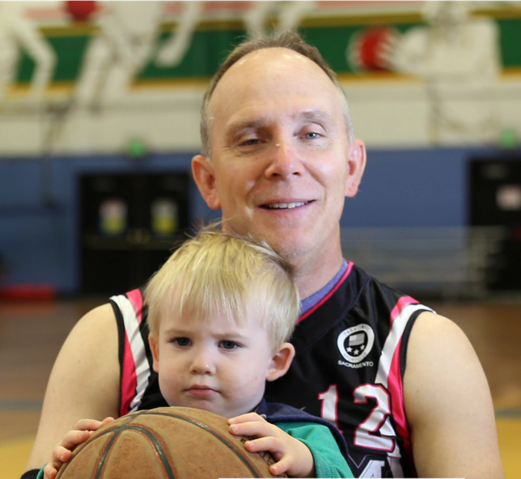
Figure 3. California Storm quad rugby player Ed Olsen and his son.
Q: Why is wheelchair rugby important to you?
A: Quad rugby has always been a big part of my life. It forces you to work out and stay in shape year round. You have to lift weight and do cardio because you go up and down constantly on the court. There’s teamwork and genuine camaraderie on the teams.

Q: How has the sport impacted you?
A: It helps build independence and mental outlook. This sport is good for you physically and mentally. You’re always planning for the season, a tournament, and maybe nationals. There are so many opportunities. But if you want any playing time, you have to earn it. I need to work harder the older I get and I plan on playing until I can’t play anymore frankly.

Q: Why do you think adaptive sports are important?
A: We have a new young player on the team and I think it’s been good for him to see people that are going for it. He can see that people at practice exercise, have a job, wife and kids, and life goes on. He’s from a community where there may not be many quads for him to interact with and I think it’s opened his eyes to what’s achievable. Personally, when I was first injured and going through rehab, one of the doctors that I encountered was in a wheelchair that left an important impact on me.

Partner Highlight: When TheCIL first moved to Alameda, the Alameda Recreation and Parks Department was one of the first to reach out about making their programs more inclusive. They’ve supported our quad rugby team with gym space, now offer a beach wheelchair at Alameda shore line, and as part of their commitment, they host us for their staff trainings so that their team is updated on adaptive technology and can best serve the diverse Alameda community.

Empowerment through Access

Led by Margie for the past 20 years, TheCIL Residential Access Program is the longest running program of our agency. The program offers consultations and builds or installs various home modifications in Berkeley that includes exterior lifts or ramps, grab gars, flashing doorbells, tactile stair tread, and much more. Access is an important not just for individuals with disabilities, so that they may go to school, work, or hang out with friends, but it’s also important that the community has access to individuals. As a result of these home modifications, individuals gain independence, build confidence, and can share their talents with the community.
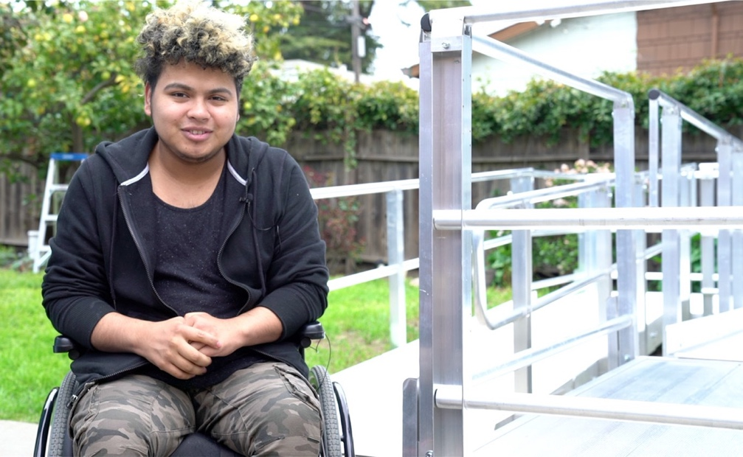
Figure 4 Luis next to his ramp.
Luis is a 20 year old resident of Oakland. Youth Alive, a nonprofit in Oakland that works with victims of violence, referred him to TheCIL. He has received a ramp, learned to navigate his wheelchair, and even participate in adaptive sports.

Q: What does the ramp mean to you?
A: The ramp has been a huge help. I have been able to meet up with friends and do more things independently. The ramp has helped me see that there still are opportunities and I can continue living my life.

Q: How has having the ramp impacted your life?
A: One of the first things I want to do is improve my English. I’ve enrolled in school and plan to obtain my GED. I’ve also always had a love of sports because I like being active and doing things. These are the main things right now that I can foresee myself getting involved in. There's other things that may present themselves as opportunities as he goes on.

Q: What is your advice to other young people with disabilities?
A: Things are not impossible even though they may seem. Have faith and put in practice. It may be hard work and that it's not necessarily going to be an easy, but it’s still possible to realize your dreams. The journey may just be a little bit different.

Partner Highlihgt: Youth ALIVE! is an Oakland based nonprofit that works to prevent violence and create young leaders.Their youth leaders, mentors, case managers, counselors, and interven- tion specialists work together to help violently wounded people heal themselves and their community. When a person has acquired a physical disability, TheCIL provides additional support for them.

Empowerment through Peer Counseling

The CIL’s CORE Services adopts the cross-disability approach and the peer-based model that are central to the Independent Living Philosophy. Staff with disabilities support others with disabilities to become more empowered via sharing knowledge of resources, disability life experiences and goal-setting.
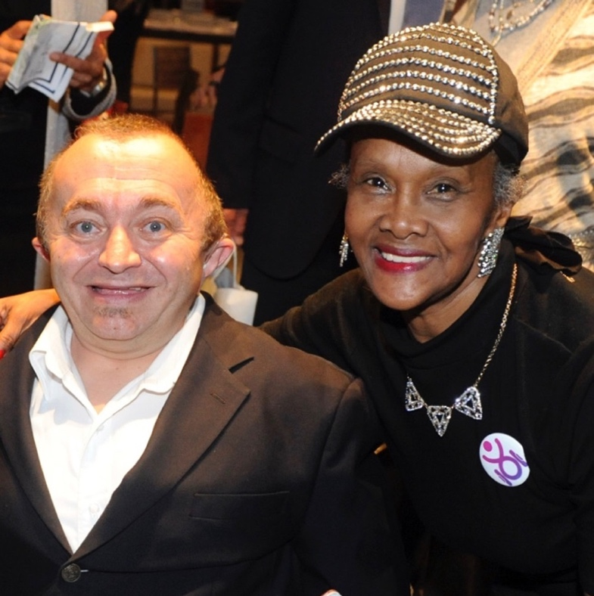
Figure 5 Mary and CIL Executive Director Stuart James at Ed Roberts Awards.
Mary is a longtime Berkeley native that found herself in a housing situation. Through peer counseling with Grace Wright, Living Well Coordinator, Mary found confidence and self-motivation to advocate for herself.

Q: What made you choose to come to TheCIL?
A: I met Grace at a Living Well event at a senior center. Things Grace said in the presentation made me believe there was hope; that I had a chance. When I got the letter about my apartment in the mail later on, I pulled out her business card and reached out to her. I did the right thing!

Q: How do you feel after working with CIL and Grace?
A: TheCIL has changed my life 100%. I feel human again. I was at a point where I felt afraid to leave my house because I didn't know what would happen next. I've gotten all my help through TheCIL with Grace and the supportive team of Alexander Sing, Carolyn Bonner and Janet Brown. They encouraged me and advocated for me. The staff really understand disability. It's important for people to know TheCIL exists. It's really changed my life.

Q: How has working with your peer counselor impacted your life?
A: It motivated me in such a way that I believe [in myself ] and want to do more things for myself. I gave myself the goal to do take care of my health and learn about computers. I also feel driven to help others. I want to share my experience so people know they don’t have to go through any experience alone.

Empowerment through Self- Advocacy

The CIL’s Youth Transition Program is based on the Five Pathways to Independence and is meant to help students with disabilities be successful with their transition into postsecondary life. Any qualifying youth can register to take a summer bootcamp or participate in weekly Youth Activities based on the Five Pathways.
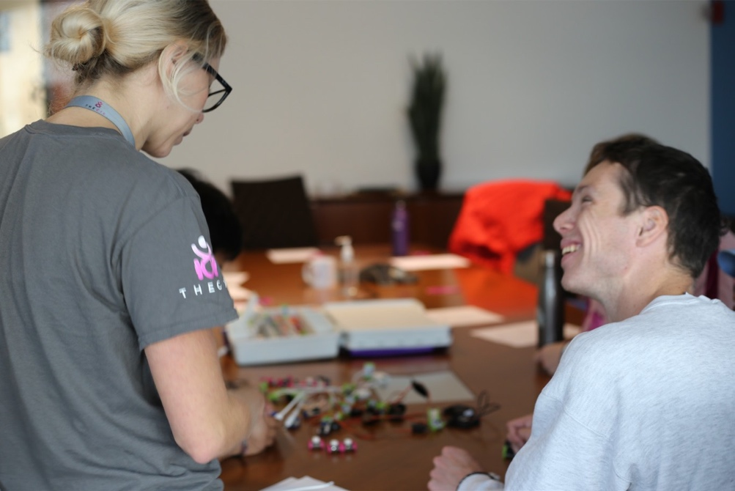
Figure 6 Program Manager Jenni and Reid.
Students are invited to mix and match activities from the Five Pathways (including sports and recreation, employment, assistive technology, and more) to create a unique program that is based on their individual needs.

Reid is a local student and an active participant in TheCIL’s youth transitions program. His dad, David, also shares how he has seen Reid change through his involvement with us.

Q: What programs have you participated in?
R: I have played Frisbee golf, attended an A’s game, yoga, and electrical circuits with the tiny bots. I liked the yoga a little bit more because it helps me calm down a bit.
D: Yeah, and he’s been doing it at home in the mornings.

Q: What did you learn from the programs?
R: I learned about myself. I learned how to use my own skills to try new things.
D: What about interacting with people?
R: Yeah, interacting with people and getting out in the community too. I have also made new friends through the program.

Q: As his father, what do you think has been the most impactful for Reid?
D: He's definitely gaining confidence and I think he's doing a better job of advocating for himself. He looks forward to getting out and doing things. This helps to broaden his horizons. As special needs kids get older, it’s nice to have other activities [outside of school] where they can go have a social life, interact, learn, and make new friends. It’s been great to see Reid more independent. It’s exactly what we want for him.

Program Highlight: The Social Club is one of Bay Area’s first group for 14-24 year olds with intellectual/ developmental disabilities who are interested in having fun and creating lasting bonds with people just like them. The group meets once a month to explore different activities in the Bay Area and creates lasting friendships along the way.

TheCIL in the Community

Police, Safety, and You
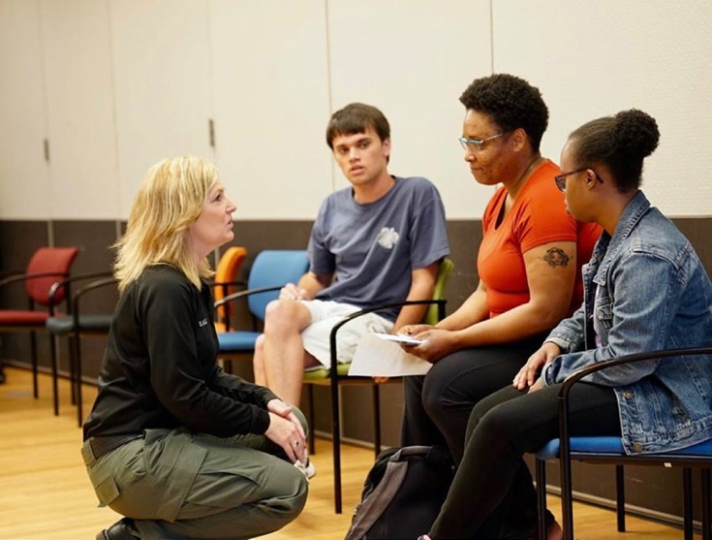
TheCIL hosted an interactive workshop with partners in disability organizations, civil rights organizations, and law enforcement to discuss maximizing safety in inter- actions between police and youths with disabilities.

Thank you to Officer Hank Morten from Alameda Police Department, Lieutenant Mike Hayes from BART Police Department, Tunisia Owens from Ella Baker Center for Human Rights, Andrea Prichett from Berkeley Cop- watch, Sandra Regan from Regional Center of the East Bay, and Susan Gonzalez from Deaf Counseling Advocacy & Referral Agency.
Figure 7 A law enforcement officer kneels to speak with two event attendees.

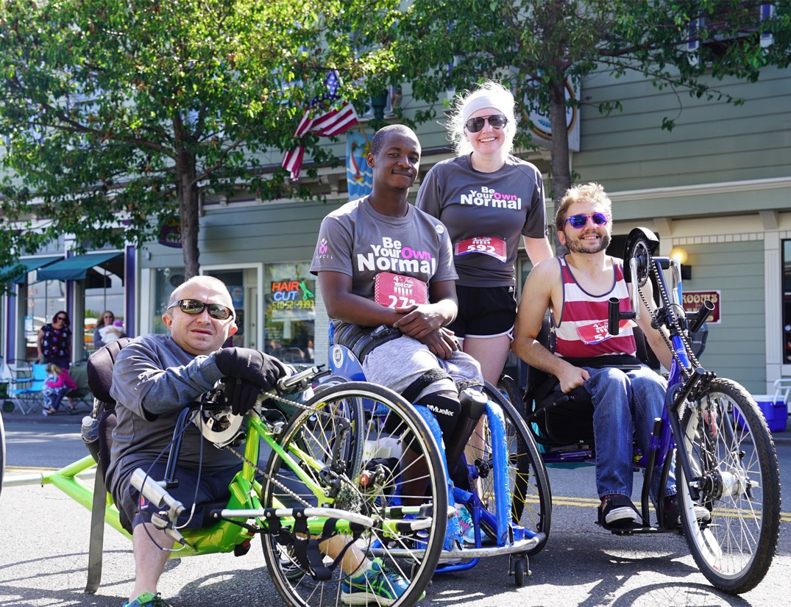
Figure 8 Executive Director Stuart James pictured here with three other participants.
ALAMEDA 4th OF JULY RACE

TheCIL team joined Alameda Mayor Herrera Spencer in a 5K in support of the Midway Shelter for women and children. Our team of
13 runners and cyclists completed a combined total of 60 Kilometers!

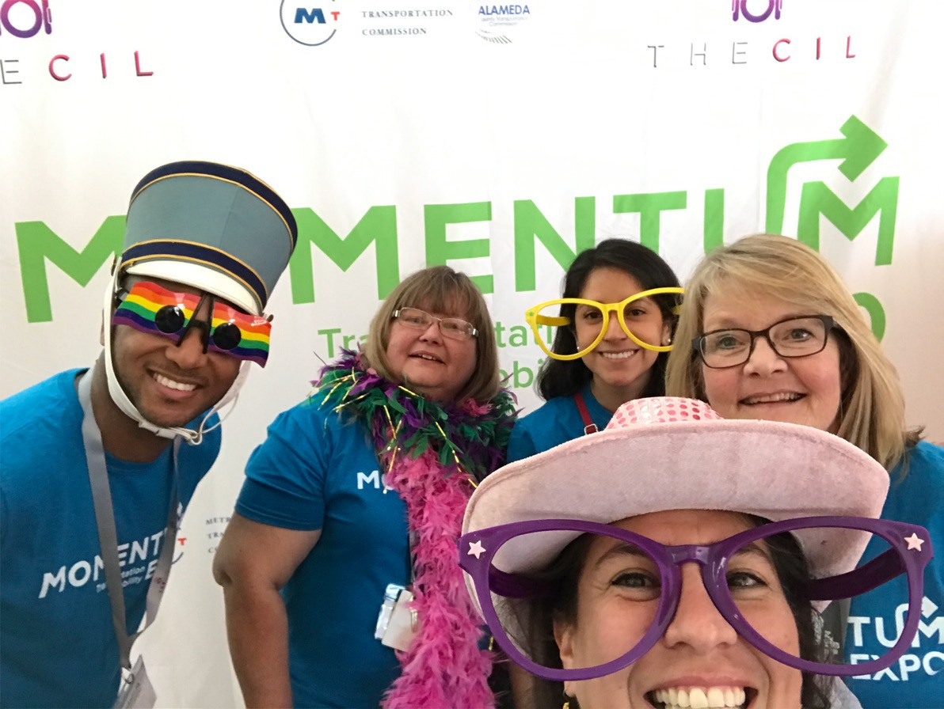
Momentum Expo: A Transportation and Mobility Showcase
Figure 9 A selfie in a Momentum photo booth of five people. Each individual has something silly: oversized glasses, boa scarves, or upside down visor. The background is a large banner that says Momentum Expo.

The event aims to empower people with disabilities of all ages and their families to get out, to get moving, and to actively explore their community. Hosted at the Ed Roberts Campus, the event had 250+ in attendance and 200 more through a Livestream broadcast to see cutting edge technology, meet vendors, and interact with other community organizations.
Book mark April 27th for Momentum Expo 2019!

Financial Review

REVENUE  CONTRIBUTIONS | 2017 -2018
Individuals | $51,943
Bequests | $301,000
Organizations & Foundations | $22,133
Businesses | $22,424
In Kind | $60,000
TOTAL CONTRIBUTIONS | $457,500
GRANTS  Government | $1,932,381
Foundation | $13,066
Endowment | $279,527
Fee For Service | $15,305
Other Revenue | $7,015
TOTAL GRANTS | $1,945,447
TOTAL REVENUE | $2,704,839
EXPENSES
Program | $1,767,019
General & Administration | $751,363
Fundraising | $104,916
TOTAL EXPENSES | $2,623,298

Thank you to our supporters

5,000+  Follette-Olivieri Family Fund  Gerson Bakar Foundation  Kaiser Permanente  Michael & Lee Callaham  Panoramic Interests  Ruth Arnhold Endowment Fund  Thunen Family Foundation  1000+  Alameda Alliance for Health  Alameda County/ Keith Carson  Anonymous  Arthur J. & Mary Jo Shartsis  DR Behest Fund  Joan Hancock  Judith Wald  Koret Foundation  Loni Hancock & Tom Bates  Schwab Charitable Fund  Weiss Associates  William & Joanne Larkin  Zalec Familian & Lilian Levinson  500+  Armando Viramontes  Equal Justice Society  James Fousekis  Jennifer Kern  Jerome Solberg  Karen Meryash  Leddy Maytum Stacy Architects  Lewis Feldman  Louie Haas  Marian & Roger Gray  Ted A & Patricia Dienstfrey  Triumph Foundation  Vanguard Charitable  David Wilcox  Denise Reddy  Donna Hopson  Dorinda Gordon  Eric Broque  Eric Strauss  Erick Mikiten | 250+  Gerald McCarthy  A.V. Gratch & Beverly Cheney  Allen Baum  Anne Henny  Arizmendi Arizmendi  Barbara Zubrick  Carol Weinstein  Charles Schwab & Company., Inc.  G. Steven & Gail Martin  Jennifer King  Joan Costello  Joan Leon & Ramon Jimenez  Katherine Sherwood  Mitroff & Associates  Nancy L. Ober Alward  Peter Celliers  Susan & Joseph Daly  The Jewish Community Foundation of the East Bay  Thomas Job  Zona Roberts  100+  Ken & Carolyn McManigal  AC Transit  Alex Broque  Alex Iantuono  Alice Creason  Allen M Daley JR  Amazon Smile Fund  Andrew B. Wallach  Anita Aaron  Anna Basallaje  Beatrice Burgess  Betty Alford  Bob Franklin  Brenda Hillman  Brendan Irvine-Broque  Carol G. Olson  Carol Silva  Carole O'shaughnessy  Chris Cook  Dale Fousel  Daniel Iacofano  David & Marilyn Nasatir | David & Rachel Biale  Margaret Wooster  Mary Greene  Maureen Fitzgerald  Melissa Male  Nancy Lane  Nita Crow  Noemi Levine  Owen Cooper  Pamela A Stiles  Pat Baker  Patricia Orr  Patsy Slater & Richard Mains  Patti Sharkey  Paul Grossman  Peter Bank  Peter Dale Scott  Peter Nussbaum  Rich Lindquist  Rita Maran  Robert Haas  Ronald & Caroline Peters  Ronald LeGaux  Rosalind James  Ryan Lau  Sara Cleveland  Sara Grignon  Sarah Marquez  Schuyler & Susie Bailey  Sophie Hahn  Soya Mori  Stephanie James  Steve Lustig  Susan Schweik  Susan Stoddard  United Way California Capital Region  United Way of the Bay Area  Voss & Marilyn Milloway  Walter Gorman  Wendy & Robert Bergman  Wigbert Siekhaus  William Monsen  William Toaspern  Estefan Vazquez  Fidelity Charitable Gift fund  Francis Frederick, Jr.

Gail Rubman  George Hisert  George Krevsky Gallery  Giovana Giscoma  Giving Assistant  Hedda Nguyen  Helen & Paul Chapman  Howard & Cindi H. Goldberg  Huong Nguyen  Jacqueline K. Curtis  James & Catherine Nemechek  Jan Pawsey  Jarett Wilkins  Jay Mullen  Jean Levin  Jen Sevillano  Joan Leon  Joan Sullivan  John H & Beverley H Polt  John Larkin  John McCallum  John Richards  Jon Gilgoff  Joyce & Sidney Putnam  Joyce Lashof  Judy Heumann  Karen Nakamura  Karen Weil  Kathleen Shingleton  Kenneth Holmberg  Kim Poolman  Kristi McKenney  Kulitbulilit Fernando  Laurence Fischer  Laurence Walker  Laurie Craise  Lawrence Livermore National Laboratory  Leanne Plum  Linda Perotti  Lisa Carlin  Lori McLeod  Lorrie Beth Slonsky  Madson David  Marcy Whitebook  Margaret & Contee Seely  Margaret & Drew Robarts | Public Funding  Alameda County Behavioral Health Care Services  Alameda County Transportation Commission  California Department of Rehabilitation  Caltrans  City of Berkeley  City of Oakland  Metropolitan Transportation Commission  Regional Center of the East Bay  US Department of Health & Human Services, Title VII C  In Kind Support  21st Amendment  California Academy of the Sciences  Cheeseboard Collective  Claremont Hotel and Spa  Commodore Cruises and Events  Dashe Cellars  Freight and Salvage  George Krevsky Gallery  Kitchen on Fire  Oakland Zoo  Pinot’s Palette  Sonoma Canopy Tour  San Francisco Giants  St. George’s Spirits  Southwest  UC Theater

How to Get Involved

- Make a recurring gift
- Attend an event
- Make a planned gift
- Volunteer
- Become a corporate partner

Tweet from @franklinminty on 08/28/2018
Attending the launch of the SF Chapter of AbilityForce. Learning about accessibility and inclusive design. I’m delighted to support all orgs, and host @TheCILOfficial @TheCILOfficial #SalesforceEng #EqualityForAll @SalesforceEQ

Facebook Post from @gregg.leonard.1 on 10/4/2018
"We've had an amazing experience working with the team at TheCIL. The awareness training Astrid and I participated in there was so informative and vital for us..."

Ed Roberts Awards 2019
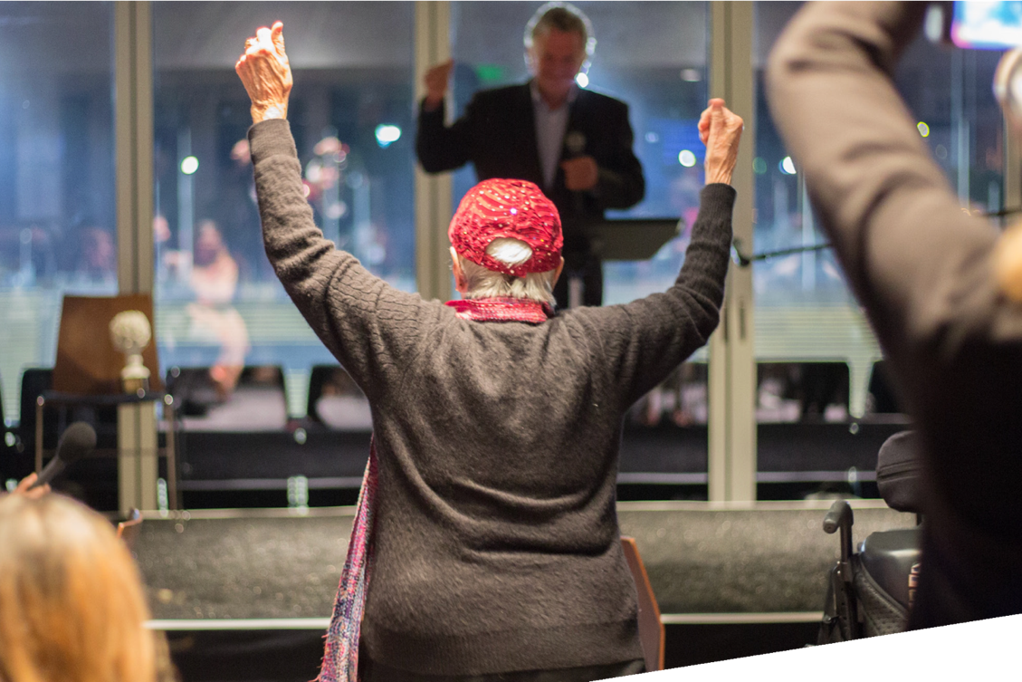

Figure 10 ZONA ROBERTS WALKS TO THE STAGE TO RECEIVE HER ED ROBERTS LIFETIME ACHIEVEMENT AWARD FROM PRESENTER LOWELL BERGMAN.

With 300 attendees at a sold-out event atop the Memorial Stadium, the 2nd Annual Ed Roberts Awardees were presented to UC Berkeley professor of architecture "grandfather" of universal design Raymond Lifchez and accessible travel blogger of "Curb Free with Cory Lee", Cory Lee Woodard for their work in making the world more supportive and inclusive for us all.
Additionally, a Lifetime Achievement Award was presented to the magnificent Zona Roberts for her longtime support of disability rights and the independent living movement.
Thank you to our sponsors: Kaiser Permanente, Panoramic Interests, Alameda Alliance for Health, Alameda County Supervisor Keith Carson, City of Oakland, Equal Justice Society, Joan Hancock, Koret Foundation, Leddy Maytum Stacy Architects, Loni Hancock & Tom Bates, and Louie Haas.

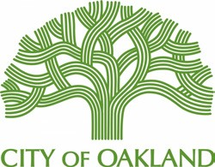
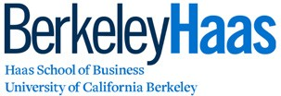
Sponsor Logos:

Back Page

OUR LOCATIONS

3075 Adeline Street, Suite 100
Berkeley, CA 94703

2490 Mariner Sq. Loop, Suite 210
Alameda, CA 94501

1470 Fruitvale Ave
Oakland, CA 94610

P: 510.841.4776 I VP: 510.356.2662
info@thecil.org I www.thecil.org

CONNECT WITH US
Instagram | Facebook | Twitter | YouTube | Linkedin

